FREQUENTLY ASKED QUESTIONS (FAQs) on the CARE International Code

- What is the CI Code?

Every organisation needs an overarching document to lay out its purpose and determine how decisions are made. The Code is CARE’s core guiding document that defines who we are, what binds us and how different parts of our confederation work together. The Code governs and guides our day-to-day work, on everything from our identity to legal matters, financing, regulations, CARE’s presence, programme approaches and so much more. It’s essentially a rulebook which outlines principles of engagement and global approaches within the confederation and holds information on the most important parts of our work.

- Why is the Code important and how does it help us?

The Code:
- binds us a Confederation with important policies and procedures, which apply to all of CARE
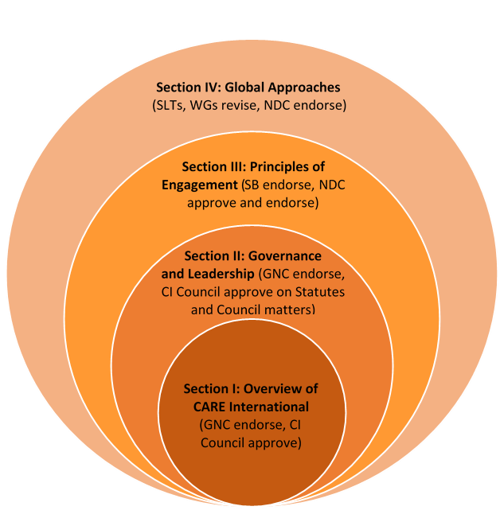
- helps to keep our work aligned with CARE’s core objectives
Figure 1- CI Code Structure
- gives newcomers an overview of CARE’s work
- acts as a resource document and provides guidance when there is confusion in decision-making
- helps external stakeholders understand how CARE works

- How is the CI Code structured?

The CI Code is divided into 4 sections (see Figure 1):
- Section I: Overview of CARE International
- Section II: Governance and Leadership
- Section III: Principles of Engagement
- Section IV: Global Approaches

- How do I use the CI Code?
The CI Code is a resource document. When you are unsure about a global policy or approach, the CI Code may have the answer.

- Where do I find it?

The CI Code is currently housed here but will be available on a shared online platform as soon as it is developed.

- Why was the Code changed?

The CI Code has been changed several times since the founding of CARE International. Its’ most recent revision was in 2018 with the aim of updating it to reflect our current realities in addition to the aspirations of our 2020 vision. The Code is now a more accessible document that can be used to orient newcomers as well as shared transparently with partners and allies. It is also designed to enable greater agility, recognising the pace of change that characterises the global landscape and nature of CARE’s work.

- Who made the changes to the Code?

Changes to the CI Code have been a result of extensive consultations across the Confederation. Strategic Leadership Teams, relevant Working Groups, the National Directors’ Committee, the Supervisory Board, Council, and its Governance and Nominations Committee, have all been involved in different aspects of the CI Code. In addition, a small strategic review body, representing a diversity of perspective from different parts of CI, reviewed the structure, approach, Sections I, II and emerging content in Section III and IV as a whole, to ensure coherence and to identify where further work still needs to be done. This group was also tasked with identifying key outstanding issues and recommending areas requiring further development.

- Who does the new Code apply to?

The CI Code applies to all parts of CARE International. Members and any offices that they are responsible for managing, are accountable for upholding the obligations, principles and agreements described herein. Affiliates are bound by Section I and Section II as well as key elements of Section III and Section IV, as determined by their specific Affiliation Agreements. Candidates are responsible for working towards meeting the obligations, principles and agreements of the CI Code in the timeline defined in their Transition Agreements.

- What are the key changes I need to be aware of?

